**EONTA: A Web Based Compositional Utility for Immersive Audio Environments**

Submitted in partial fulfillment of the requirements for the

Master of Music in Music Technology

in the department of Music and Performing Arts Professions

in the Steinhardt School of Culture, Education, and Human Development

New York University

Advisor: Dr. Tae Hong Park

May 25th, 2016

**ABSTRACT:**

Stemming from the widespread availability of GPS in smartphones, as well increasingly advanced location based open-source development tools, the previous decade has witnessed a great deal of modernization to how GPS based software is experienced. With regards to GPS and music, there is a rich and widely unbeknownst history of topographical sound studies that explore non-commercial avenues of creating Immersive Audio Environments. The Eonta prototype in an online GPS based audio authoring platfrom that was developed for the artist, composer or novice technologist to build multi-track sound installations using a Google Maps API. This document describes the intention behind its development as well as future insights into its potential.

**ACKNOWLEDGEMENTS:**

I’d like to thank my parents for the endless support they’ve given me. Thank you to my advisor Tae Hong Park for cracking jokes that stopped me from stressing out. Miss you Mtech kids already and shout out to my Pullman People. Huge thanks to the department for this opportunity, best of luck to all.

**I: INTRODUCTION:**

There will almost certainly never be a consensus as to whether being taken out of your comfort should be considered a good thing. But there remains an aspiration for those who do, to garner a sense of being outside of themselves for a moment, and often this vacation is derived from a musical experience. Not just for the music itself, but also for the context with which the music enriches that is novel to them. Those who purse composition or production make it their life’s work to convey this context to others. But in the author’s experience, the association is very subtle, and often meticulously complementary to their current environment.

Smartphone advancements, specifically with GPS, are most commonly the first reference given to the modern rise in services that offer you a deeper insight into your orientation with your surroundings. Which is certainly true, but it also prevails deeply in our culture with Yelp telling you what’s good and Postmates bringing it to your door. There exists a lot more beneath the surface, however, in light of the vast number of artists and technologically savvy creative individuals who have utilized GPS for imaginative performance or installation pieces.

**1.1 MOTIVATIONS:**

Eonta is a web based application that aims to encourage the creation of Immersive Audio Environments. It is a Node.JS prototype that allows users to upload compositions onto navigable spaces, then allows them to explore the aural space based on location-based tracking. Eonta is by no means the first application to have done this, yet in this paper the author has documented the way with which it offers functionality that is not easily available to those who don’t build the software environments themselves. The goal of this paper is to provide the context for why Eonta offers a unique component to the progression of location-based media authoring software.

**II: LITERATURE REVIEW:**

**2.0 INTRODUCTION:**

Considering so many past works involving site-specific audio installation are commonly contextualized within the study of augmented reality (AR), the author will incorporate an extensive degree of attention to research regarding this field. However, with the intention of allowing online-based media authorship by incorporating GPS oriented composition, focus was also given to the investigation of Internet-based platforms dedicated to one-way audio processes that utilize like-minded practices.

There are often conflicting opinions between artists and researchers as to what truly exemplifies augmented reality (which will be discussed further). Yet the various accounts - both oriented towards the arts and science - will be considered for the purpose of exploring provisions leading to the necessity for a common domain with which the personal creation of real-time location-based sound installations could be applied.

There have been a great deal of artists and researchers who have lain the foundation for either AR or navigational listening systems in this particular fashion – using a wide variety of tools and methodologies. That being said, there is still yet to be the existence of a dedicated consumer level multi-tracking platform that provides users with the ability to compose their own GPS based sound installations.

For those who are not oriented towards programming, the ability to sculpt a sonic environment is met with a certain degree of difficulty, leaving the field mostly confined towards academic researchers and professional media artists. Although there is a large degree of engagement by the general public towards augmented reality and immersive audio environments, there remains to be a lack of user-friendly compositional methods.

**2.1 GPS OVERVIEW:**

As scientists discovered in 1957 that the increase and decrease of the radio frequencies coming from the Russian Sputnik satellite – a result of the Doppler effect – the possibility to measure and track the distance and position of orbiting satellites was realized (Sullivan, 2012). In order to accurately track a specific position, a minimum of 4 of the 24 active satellites orbiting earth must be in view of the receiving object – three satellites to capture the object’s position and an additional satellite to calculate the clock deviation from the satellites’ time.

Prior to the year 2000, the American military was scrambling GPS signals as a security measure, however president Clinton signed an ordinance that allowed for civilian use with the level of military precision. GPS is now completely pervasive in our society through the use of consumer electronics and, most notably, smartphone applications. (Wong, Tanaka, 2014).

**2.2.0 EARLY USE OF GPS AND AUDIO:**

Initial stages of utilizing GPS for audio applications stemmed from its ability as an accurate clocking mechanism. At the end of the 20th century, Timothy B. Thompson was utilizing the atomic clocks from satellites to create high precision phase-alignment of audio tracks being played in studios from across the globe. Creating these Universal Time-Stamps as a means of temporal and frequency references through GPS was an inexpensive means of building and effective Audio Wide Area Network (Thompson, 1998).

**2.2.1 GPS IN PUBLIC BROADCAST SYSTEMS:**

The use of GPS and audio for public announcement systems and other civil applications was also examined in the nineties by Swiss researcher Markus Erne. Given GPS’ ability to provide all-weather access around the world to corresponding receiver, it was found to provide substantial support to cut through ionospheric noise, making it a common integration into emergency systems and portable audio devices.

At the time, many public transportation and airplane broadcast systems were still reliant on analog recording media, so the integration of a location based signal tied to a solid-state recording device was extremely useful to pass on information based on the device’s position and time of day (Erne, 1995).

**2.4.0 GEOTAGGING, SOUNDWALKS & GPS BASED INSTALLATIONS:**

Initial applications of GPS related media included the embedment of data for the storage of GPS coordinates and subsequent location based information, “Geo-Tagging”. This can be applied to any form of digital media using an access-controlled log file on a smart phone or GPS equipped device. For an audio file to contain encoded location, date and time information on a smart device, it is required that the data is identifiable in each band-limited frame of the audio file’s spectrum (Wong, Tanaka 2014).

**2.4.1 EARLY GPS BASED SOUND INSTALLATION:**

In addition to Geo-Tagging, various artists in the late nineteenth and early twentieth century showcased a great deal of interest in utilizing GPS for sound installations that were navigable by the subject/patron. A commonality among these projects were the direct linking of coordinates to audio files, which must be “discovered” by individuals wearing the appropriate technology to experience them (Janer et al., 2011).

One such artist is a Rhode Island School of Design professor named Teri Reub, who employs large-scale outdoor environments on which they create a sonic map. Reub focuses on site specificity and the coupling of content with the physicality of the environment they’re working with. Access to these sounds is completely dependent on the presence of the listener in the environment and their respective mobile technology.

Reub’s first installation, entitled *Trace,* was created in 1996 and was made available until 1999. It was located on various hiking trails throughout the Canadian Rockies and required participants to wear GPS equipped backpacks in order to hear the material. The piece was intended to present a sort of invisible sonic mausoleum, by triggering a series of memorial songs, poems and stories throughout the trail. The installation also allowed for contributions by other artists, who could add to the content that was incorporated into the sonic trail (Reub, 2002).

**2.4.2 EARLY AUGMENTED REALITY:**

*Wasser* (meaning water) was an audio environment conceived by German artist Stefan Schemat, who framed the project as “augmented reality fiction”. It was presented at an exhibition in 2004 entitled Ohne Schnur – Kunst und Drahtlose Kommunikation (Cordless – Art and Wireless Communication) in Cuxhaven, Germany. Taking place along the coastline of an estuary leading into the North Sea, Schemat also provided participants with backpacks containing a laptop, headphones and a GPS device with which they would explore the environment and receive site-specific fragments of an ongoing narrative – a woman who has disappeared and is asking the listener to search for her.

The implication of augmented reality stems from the woman’s voice describing specific landmarks related to the region, imploring the participant a feeling of moving through a living film. However, there is no linearity to the piece and no specific sequence in receiving the text. Aside from the fact that spatial proximity to specific text objects increases the likelihood that the listener will wander into related territorial subjects, the audio does not have any preprogrammed correlational features (Kwastek, 2013).

**2.5.0 AUGMENTED REALITY vs. IMMERSIVE AUDIO ENVIRONMENTS:**

Both Reub and Schemat described their installations as demonstrations of AR, yet these systems of presenting audio in a purely recipient fashion do not necessarily meet the traditional criteria of the true definition of augmented reality. The distinction between augmented reality and that of immersive virtual audio environments is a result of the latter being an entirely different acoustic environment than the one occupied by the participant.

In order to designate a system as Wearable Augmented Reality Audio (WARA), there must be the involvement of a two-way transducer system that incorporates auralization techniques, allowing for the present acoustic space of the subject to remain relatively intact. Since virtual acoustic environments are completely artificial, it traditionally is not regarded as AR.

**2.5.1 WEARABLE AUGMENTED REALITY:**

In Harma et al.’s paper regarding “Techniques and Applications of Wearable Augmented Reality Audio”, they even go as far as to suggest that the a true WARA system should pass an equivelant “Turing Test” for realism, meaning no latency or discernable distinction from the subject’s environment (Harma et al., 2003).

That being said, though the intention of many location-based sound artists is to create an immersive/”filmic” experience, the features of the audio tend to be very site specific and provide an alternative outlook to one’s sense of their environment. The difference is most notable in the various applications of the research within the field. Compositional and narrative pieces appear to rely more heavily on virtual immersive experiences, while AR based applications are by nature more exploratory in regards to environmental interfacing. Such AR applications could include the use of game production or control, acoustic reproduction of other environments, or navigational systems for the visually impaired (Karjalainen et al., 2004).

**2.6.0 AUGMENTED REALITY AND GAMES:**

A common example of AR location based gaming is *Viking Ghost Hunt,* which was prototyped in Dublin in 2010 for the Android mobile platform. The game utilizes the player’s GPS coordinates, as well as a 3-axis compass, in order to discern their location and directionality; while acting as a paranormal investigator and receiving aural and visual cues in the exploration of a physical space. An emphasis in the sound design process was on preserving the original acoustics of the environment, while realistically balancing the sampled and synthesized soundtrack provided by the game. The developers managed all audio files heard by the user into the SoundPool class, which generally provides audio resources for Android applications. While the MediaPlayer class was attempted, it resulted in latency and looping issues.

The GPS information was incorporated by the creation of various trigger objects that radially surrounded the player’s device, continuously updating in order to define the player’s proximity to each designated point. In order to mitigate the sound of the real world with that of the game’s soundtrack, the developers applied psychoacoustic properties – the use of Head Related Transfer Functions - to the audio in relation with the player’s position and direction (Conway, 2010).

**2.7.0 GPS FOR MUSICAL COMPOSITION AND SOUNDSCAPES:**

A common present day utilization of GPS based audio application has been in the realm of musical composition, and in turn the subsequent user-based performance. In 2011, a great deal of media attention was given to Bluebrain - two Washington D.C. musicians Ryan and Hays Holladay - for creating a series of interactive musical scores entitled *National Mall* and *Central Park (Listen to Light)* (named after their respective locations). By assigning and layering tracks of musical instrumentation to specific pockets of each region, the listeners were able to experience a piece in the form of a meandering composition that behaved accordingly to their position. As of yet, the Holladey brothers have contributed a great deal to bringing this technology to mainstream listeners – having given a TED talk in regards to their production processes (cnet.com, 2011).

**2.7.1 SOUNDWALKS:**

Another large-scale organization dedicated to providing navigable scores and touring audio installation pieces is the artist cooperative Audiotopie out of Montreal. This artist collective frame their work as an extension of landscape architecture, and offers custom installation work as a commissionable service - specifically in the production of audio-based guides and tours as well as electroacoustic musical landscapes.

The “soundwalks” they have designed are award-winning explorations of urban environments, pairing elaborate compositions to various landmarks around the world (audiotopie.com, 2015). This trend of building immersive soundscapes as a means of gaining a new appreciation of existing spaces is a strong commonality of many subsequent collectives dedicated to the practice of location-based composition. Though the commercial nature of their services provides a limit as to what can be experienced by the public. Other such productions such as *Syren* -a sound installation that was adopted onto a cruise ship in the Baltic sea – demonstrates how this composition of GPS related material, outside of an academic setting, is unsurprisingly oriented towards industries relating to tourism (Conway, 2010).

**2.7.2 COLLABORATIVE SOUNDSCAPES IN ART:**

In contrast to the commercial setting, there also exists a vast user base dedicated to building collaborative soundscapes. Examples include Second Life tools, such as the Metaverse1 project, which accurately applied a real soundscapes into virtual environment. Janer et al. has aims towards the creation of compiling transferable acoustic spaces into a user-contributed repository for AR purposes.

They liken the potential of such a repository to that of *freesound.org*, an immense global community that shares samples and field recordings freely. While relying on position updates of their user base, these soundscape could be freely explored simultaneously by users globally, where they could experiencing the same artificial spaces in their respective locations (Janer et al., 2011).

**2.8.0 CONCLUSION**

As the availability of mobile technology has become an ever more prevalent aspect of society, the playing field for utilizing the full extent of mobile software for creative purposes has never been more open. Given the breadth of the recent history of GPS related applications, and the expanding communities of interested parties, it is surprising that there is not a more widely available platform for the authorship of the aforementioned works given to the general public – specifically in relation to musical composition. The intention of the author towards research in providing a multi-tracking audio software that utilizes the essential tenants of virtual immersive audio as well as augmented reality applications, is to allow a larger population of musicians and producers to experiment with expanding their sound creations to another realm of experience.

**III: METHODOLOGY:**

**3.0.0 OVERVIEW:**

The GPS based multitracking software produced by the author is entitled Eonta*,* in tribute to the 1964 composition by Iannis Xenakis. The software consists of an interactive graphical user interface, a database for referencing audio files and compositional structures, an open source GPS mapping Application Programming Interface (API), and a host server for the audio files being played back. Figure 1 illustrates the conceptual functionality of the system, including UX perspectives from both the composer and the listener. Structurally speaking, the application is in essence a one-page Model View Controller (MVC) framework utilizing a node server that serves assets, signs requests and connects to a database utilizing a JSON API.

**3.0.1 INTENTIONS FOR PRODUCTION:**

Considering the wide number of studies and installations involving topographical composition systems, the author believes it is a natural progression for this methodology to orient itself towards those who are artistically inclined yet do not have the skillset to code the environment for themselves. This necessitates a user-friendly application that allows for the creation of GPS linked audio, allowing for maximum control over the production with the use of tools that are easily understood.

Given the wide spectrum of research presented in section 2, the author believes that the creation of a multitracking platform with a minimal learning curve - letting users arrange and layer a composition in tandem with a mapping API – fulfills an essential position within this niche field of study. Whether the intention is for sound installation, scoring a specific trail or pathway, or creating an album out of a landscape - the possibilities for topographical immersive audio are very extensive. This section will describe the process of how Eonta was implemented.

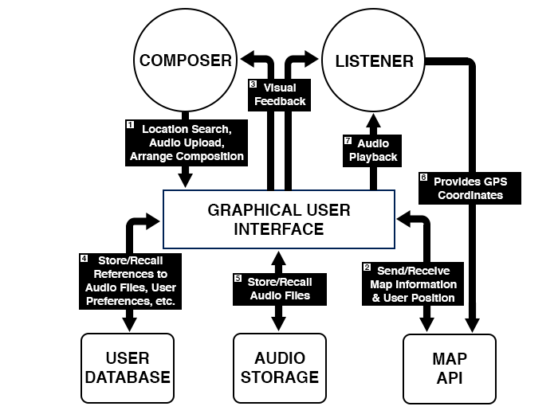

**Figure 1. - Schematic of the *Eonta* system.**

**3.1 FUNCTIONALITY:**

Eonta is a web based audio application that will allow for participants to either compose their own topographically based sound installations, or have the ability to experience pieces created by others. The initial UX design will allow composers to access a map provided by the Google Maps API, then proceed to navigate a location with which they will be using as their canvas. As illustrated in Figure 1. [1] & [2], after the composer chooses their location, they begin to designate boundaries onto the map using a polygon drawing tools that should be familiar to anyone who has ever used the widely popular Adobe Photoshop.

These shapes can then be overlapped in order to establish a myriad of voices over a selected region, allowing the composer to build a virtual structure corresponding to what the listener will hear in real time [3]. Upon creating the framework to the satisfaction of the composer, they are then able to upload an audio file that will be continuously looped within each particular cell [5]. Data regarding the composer’s layout of shapes, as well as the audio they upload, will be saved to the website’s database [4], thereby allowing them to travel to the real location and witness firsthand the same piece that they’ve constructed through the use of a smartphone [7]. The prevalence of GPS devices in modern cell phones allows for the website to control the media submitted by the composer and have it dynamically change in accordance to the listener’s position [6].

**3.2.0 GUI AND PROCEDURE:**

The main prerogative for Eonta’s interface was to provide a very simple and stripped down environment so that general access to the utility will be instantly understandable by anyone with a basic level of technical skill. As exemplified in the prototype in Figure 2, the single-page environment of the prototype provides a straightforward introduction to composing topographically. The main aspect of the interface is the map, derived from the Google Maps API. This particular map API has been so heavily incorporated into countless web applications, so the navigable functions will be should be recognizable to most users.

**3.2.3 GUI OVERVIEW:**

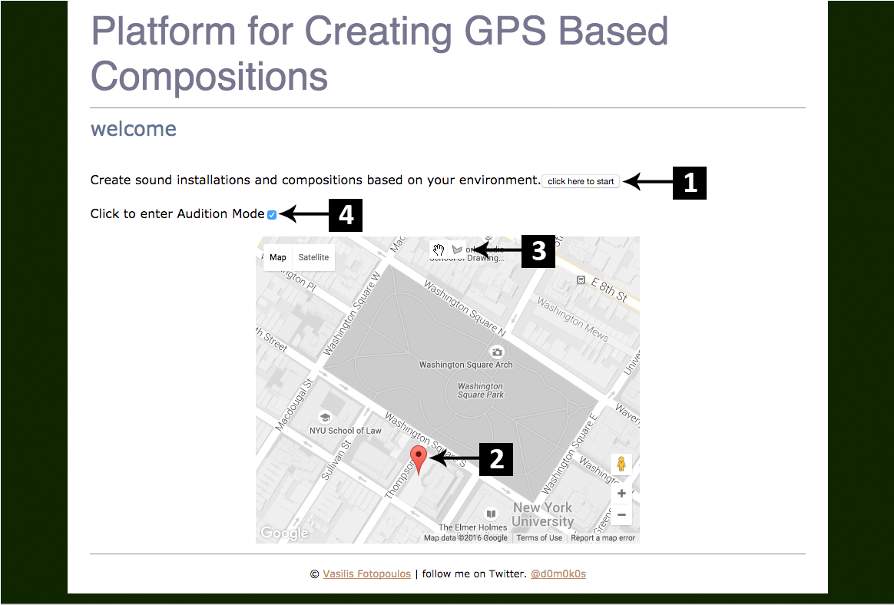

**Figure 2. - Initial state of the Eonta homepage.**

As the page loads, the maps service in Eonta’s programming attempts to gain access to Apple’s Current Location Framework location through the browser. If the user declines or if the browser is unable to detect the user’s location an error message is given. Once the user is on the blank homepage, most of their options reside within the controls on the map. However, as audio is uploaded the interface begins to grow with increased control capabilities. In order to begin using the program, the user is then instructed to hit to “click here to start” button [1], which subsequently drops a red marker that lands on the user’s position [2]. This marker acts as the universal “listener” within the application. Whether in the *Default* or *Audition Mode*, it is this marker that dictates which audio files will be playing.

The GUI map also contains the polygon boundary-building tool that makes it possible for the composer to create *cells* of overlapping loops [3], Figure 3.

Macintosh HD:Users:vasilisfotopoulos:Desktop:Thesis:Paper:Figures:EontaScreenshots:Screen Shot 2016-04-25 at 7.11.45 AM.png

**Figure 3 – Hand and Polygon boundary tools**

The user selects the hand tool when they wish to either navigate throughout the map, to reposition coordinate points of any given boundary, or when using *Audition Mode.*

When the *Audition Mode* checkbox is selected [4], Eonta ceases to read the user’s position and orient it towards the listener marker. Instead, now the user gains the ability to drag and drop the listener marker throughout the map, which will in turn instigate the same playback engine that is looking for the listener’s coordinates. This gives the composer the ability to understand how the their audio boundaries interact with each other without having to traverse the site-specific environment.

**3.2.1 CREATING AND LISTING BOUNDARIES:**

Using the polygon tool, the user - acting as composer - then begins to designate a closed boundary over a certain area of the map. Once the boundary is created, an “audio upload” prompt appears on the screen requesting the user to upload the corresponding audio file to that shape. If the user decides to cancel the upload, the boundary will be set to *null* and be deleted from the map.

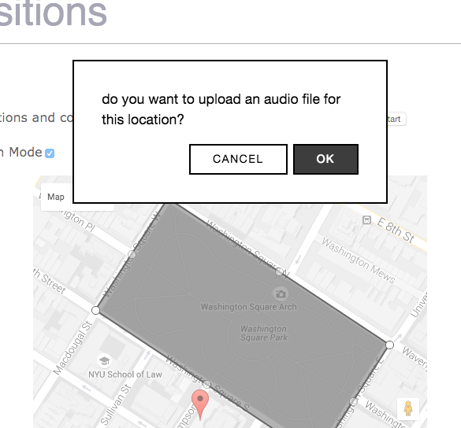

**Figure 4. – First boundary created with audio upload prompt.**

Once the appropriate sound file has been uploaded, a list will begin under the maps interface, displaying the name of the audio file. If the user wishes to delete the boundary and re-upload, a “delete” button provides this option next to the listed audio file (Figure 6.). Should a user wish to delete an audio boundary, they are first given a warning asking if they are sure (Figure 7.).

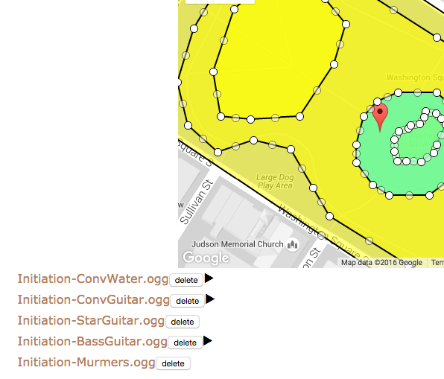

**Figure 6. – Listed and displayed polygonal audio boundaries currently playing audio.**

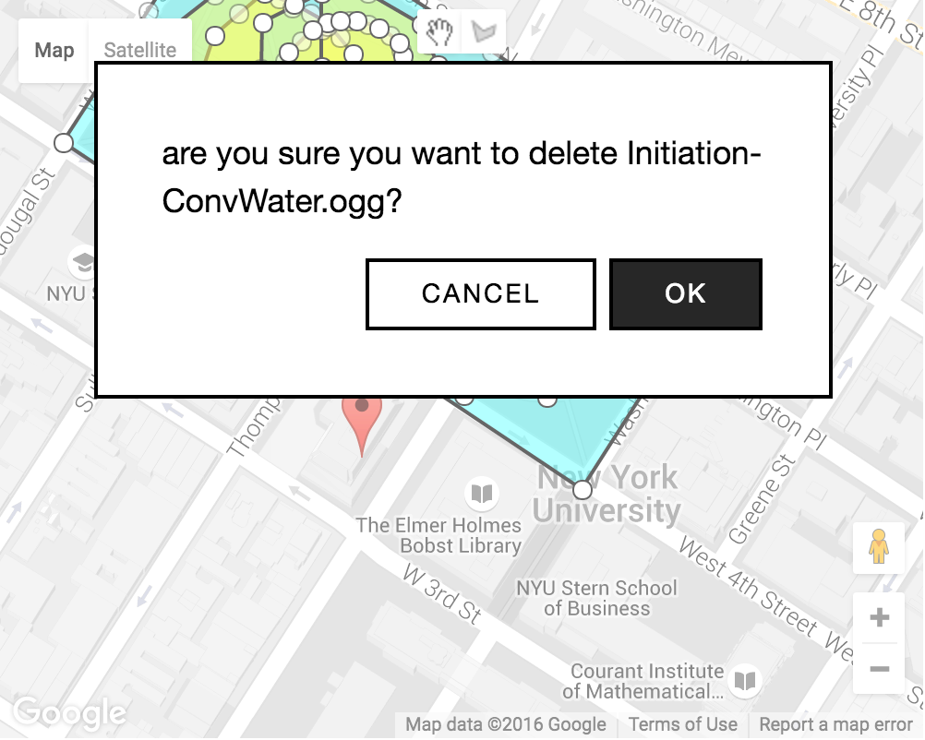

**Figure 7. – Deleting an audio boundary from the Eonta interface; removes the audio file from the list and sets the polygons array to *null***

In addition, when the user selects one of the listed elements, the corresponding shape on the map becomes highlighted so that there is no eventual confusion as to where the audio file is located. This provides the composer a means with which they can visually organize each of the stems within their composition. Finally, when a region has been triggered by the listener marker, the listed audio files that are currently playing will display a “play” triangle so that the user has visual confirmation that the correct files are playing to their corresponding boundaries.

**3.3.0 FRONT END DESIGN:**

Eonta was programmed utilizing the interplay of a variety of third-party applications, combined with the scripting of standard web languages - JavaScript, HTML and CSS.The Eonta interface was constructed using the AngularJS framework by Google. The decision for this was because of Angular’s ability for two way data-binding, allowing changes in the model to automatically show up in the view and vice versa. Furthermore, although Eonta has just one main-controller, splitting each part of the code into model view controller components becomes much simpler when channeling through angular rather than assembling them manually.

Considering the separation of the view markup, the Jade template engine was also implemented for ease of debugging and general clarity. Within Eonta’s code structure, the main controller has the ability to handle the logic related to maps, uploading, audio and the polygon boundaries by giving them their own separate services.

Additional styling considerations came from a Modal using a JQuery library called Vex, which is incorporated when the main controller calls the uploader service or when warned that they are deleting an audio boundary. The resulting display is a themed, modern looking message window, in addition to a series of quality animations between events.

**3.3.1 THE GOOGLE MAPS API:**

The power and versatility provided by the Google Maps API made it the best and most practical choice to use in conjunction with Eonta. There are a large degree of advantages and built in functionality that allows for the most flexibility and ease of use, both for the programmer as well as the user. Most importantly regarding Eonta, the design is oriented towards speed and stability with regards to mobile devices.

Another benefit is the ability to stylize every aspect of the interface, and hold a large degree of control over its UX attributes, in order to make it more visually appealing to the user. After acquiring an API key through Google Developers, there are various libraries that were attributed towards the applications build. Specifically for Eonta, the Drawing and Geometry Libraries were put into practice, however, the Places library was also added for future search capabilities.

**3.3.2 DRAWING AND GEOMETRY LIBRARIES:**

The behavior of Eonta’s polygon tool was constructed utilizing methods from the Drawing Library, which allows for customization of every single element of the creation of the boundaries’ styling and editable behaviors. The polygons created on the map function by creating and storing an array of coordinates that lock the shape to the specific geographical position on the map. The calculations required to establish the various boundaries are derived from the Geometry Library found in the Google Maps API. This library accounts for calculations regarding each shape to be utilized throughout the program given the *LatLng* objects, which specify the Latitude and Longitude of each coordinate and their distances between them and the listener.

Latitude values in this structure are given through a range of [-90, 90], where the values are fixed from the southern most part of the earth at -90 to the northernmost at 90. Longitude values, however, are given the range [-180, 180] and automatically wrap in regards to the curvature of the earth (in that a value of 200 will subsequently be read as -160) A method entitled *containsLocation(point: LatLng, polygon: Polygon);* is the most direct means of determining whether or not a specific point lies within a polygon, and is administered from this library.

**3.3.3 AUDIO & BOUNDARY STORAGE:**

As previously mentioned, when the user completes a given boundary object, they will then be given a prompt to select and audio file for upload. The audio format that will be recommended to composers is Ogg Vorbis, based on its ability to outperform other lossy compression formats at lower bitrates. The option to upload mp3’s will also be intrinsically available to users based on the proliferation of their use. WAV files and lossless formats however will not be accepted given the large file size that is likely to inhibit functionality.

**3.3.4 SAVING REFERENCES WITH AMAZON S3, JSON & MONGODB**

In order to easily upload, store, and recall audio seamlessly for the user, the author incorporated an Amazon Simple Storage Service (s3) bucket. S3 is a part of Amazon Web Services (AWS) and offers quick and reliable cloud storage, allowing for a scalable way to accept large amounts of data from users without the need for a dedicated hardware server (Figure 8.). Using S3, Eonta is capable of rapid recall of streaming audio files that maintain integrity when compounded with large stacks of audio regions.

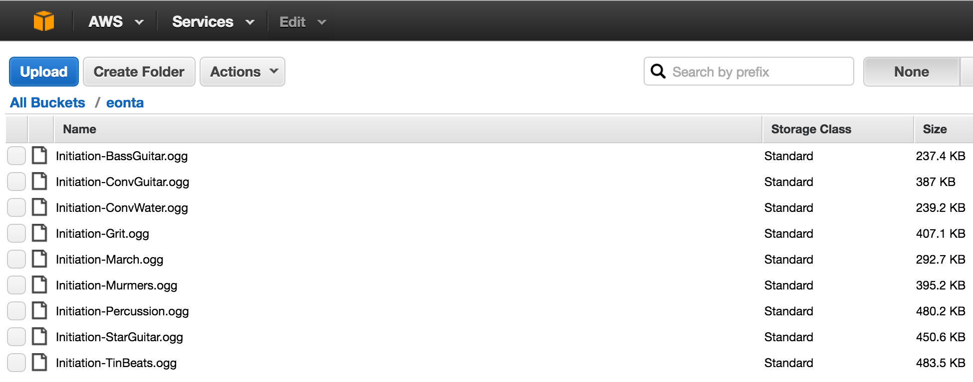

**Figure 8. – Audio files listed on the Amazon s3 bucket corresponding to Eonta’s list of audio boundaries.**

Following the user’s confirmation to upload an audio file, Eonta’s server will sign off for the request using the private key of the bucket’s account. Within Eonta’s server is JSON API, which is requested to save the name of the audio file, the URL from the s3 bucket to reference the audio file as well as the coordinates of the corresponding shape’s boundaries on the map. All of this requested information then gets saved to MongoDB – a popular and secure database.

Figure 8. shows the way in which this elements interrelate with one another: the user uploads to the s3 bucket, which creates a URL and provides access through the secure network server to the MongoDB for reference, while the server returns assets as the user interfaces with the Google Maps API.

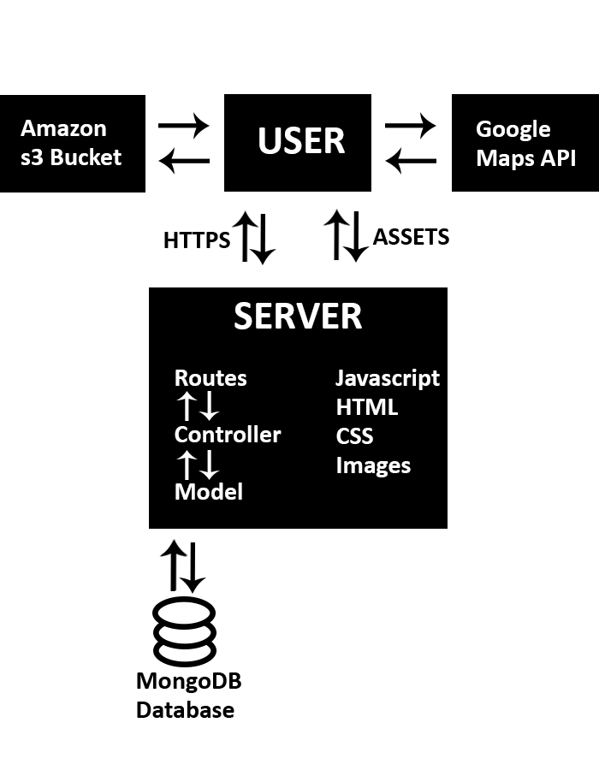 **Figure 8. - Eonta’s system architecture for data transfer, storage, access and recall of audio boundaries.**

**3.3.5 BACK END DESIGN:**

Eonta is deployed onto the cloud platform Heroku via Github. The application uses the javascript package managers NPM package manager on the back end, while using Bower on the front end. All of the aforementioned credentials utilized in the program are stored in environment variables on Heroku, where the application builds as part of a post-installation script.

**3.5.0 AUDIO PLAYBACK:**

The audio service being driven by the main controller is triggered by the listener marker as it enters the boundary of a polygon. The audio is sourced from the s3 reference URL that was originally established by the user’s upload. Once the listener mark enters the polygon, it triggers the audio service template created with the W3C Web Audio API. Within the audio service, the s3 URL is loaded into a function that decodes it before placing it into an empty buffer the duration of the audio file’s length. Afterwards, this buffer is connected back into the audio context and receives a command to loop continuously.

In the main controller, the function *seeWhatToPlay* checks to see whether the listener is in bounds and not playing. If this is the case, then the function passes the s3 URL of the audio file for that particular polygon to the audio service to play. On the other hand, if the listener is no longer in bounds and audio is playing, the audio service will be given a stop message.

In *Default Mode*, since the user’s coordinates are being recorded every second, their location will always be accurately reflect in the boundaries of any number of polygons. When toggled to *Audition Mode*, the marker that formerly represented the user’s position has an event listener while dragging, which gives a latitude and longitude message (*latlng*), back to the *seeWhatToPlay* function to check whether or not it should trigger the audio service.

**3.5.0 BOUNDARY RECALL:**

The most important element of creating an online topographic composition utility, is the necessity to recall everything the composer arranged for use on the field. In order to keep the audio boundaries on the map after the page refreshes, a model must be defined by giving it a schema in order to recreate it. In the case of the audio boundaries – a timestamp, specific coordinate points kept in an array, an s3 reference to an audio file and the audio file’s name. These references are all sent to s3 and MongoDB as soon as the polygon is originally created.

Within the polygon.js model in Eonta, a Dotenv module takes each of these environmental variables and passes them into a constructor API called Mongoose. When Mongoose receives the scheme it converts it into a workable model, which in turn is used to create new polygons through a controller and the maps service. Given the identical references, everything from the previous session will remain intact.

**IV: COMPOSITION**

**4.1 OVERVIEW:**

As is evident with a great number of those discussed in the second section, the success and interest of a GPS based Immersive Audio Environment is entirely contingent on the content with which it offers the ability to facilitate. The platform itself must inspire it’s own factum of execution, offering constraints and revelations that become evident through its continued use. In order to properly evaluate Eonta’s functionally, it became a necessary step to compose a piece using the application and evaluate the procedural roadblocks and points of supplemental interest versus available sequencing utilities.

The means with which a user compiles a piece of work through Eonta can span a very wide range of strategies and production techniques. However, with preliminary testing the author presents an arrangement that encompasses a series of methods that is believed to be the most practical given the statutes of the programs functionality.

In order to achieve the greatest level of cohesion and comprehension by the listener, it is suggested by the author to consider these guidelines while engaging this system and constructing a composition with Eonta. Furthermore, there will be a “Suggested Composition Guidelines” page on the Eonta website that will encompass many of these factors into preparing the audio tracks for upload.

**4.2 PREPARING AUDIO:**

The primary consideration for composing an Eonta audio file is that it should be constructed as a seamless loop on the musician’s DAW of choice. This depends entirely on the piece being created, however, the assumption for this piece is that in it’s experimental approach there is also consideration for historical musical conventions and practices.

**4.2.1 GRIDLESS COMPOSITION:**

By default, Eonta’s audio engine loops each audio file so long as the listener marker are within the corresponding audio’s shape’s boundaries. Loop lengths, however, do not necessarily require the same length, or even tempo for that matter. This is because there is no internal clock governing playback; each section will begin and end based on the when the listener triggers it.

In spite of the nod towards musicality, inspiration for Eonta was predominantly derived from experimental traditions of musical composition, therefore this lack of linear structuring of concurrent audio sequencing was intentional – encouraging song structures that are not rigidly bound to each other as they are to the environment.

Depending on the amount of layered boundaries there are in a given area, consideration can be given to how choreographed drops in volume or intensity within certain loops might enhance the cluster. The Web Audio API and JavaScript have, under W3C’s own admission, difficulty with real-time processing and synthesis However, with a single audio context running compressed files, it is feasible and also practical to upload longer individual files that span the course of and entire song. This allows the listener to not be fatigued by any one audio event, as well as encourages the composer to consider a more extensive scope of writing with loops.

**4.2.2 MIXING FOR EONTA:**

An additional consideration is the need to have each of the audio files to be fully prepared in conjunction with each other before exporting them and uploading them to the server. Eonta does not include any real time mixing capabilities at this juncture, so each stem of the audio files need to be fully mixed as a final, then converted to OGG or mp3 by the user before uploading.

It is also not advised to mix with any effects or dynamic processing on the master bus of the DAW being used to export stems. This will likely create disparities in gain or create undesirable results when listening back to elements in relation to one another. Consideration for this kind of issue should also be taken with mixing auxiliary processing.

**4.3.0 AESTHETIC PRACTICES:**

When constructing a piece for Eonta, the author elected to utilize Washington Square Park based on its proximity to the Music Technology program at New York University (enabling it to be a convenient location for testing). The park is also structured with a series of traversable “cells” which allow for the listener to have visual cues associated with aural boundary changes. A final consideration was that this location is always accessible, making the availability of the composition a non-issue.

The first Eonta composition is entitled *Initiation* (Figures 9. & 10.). It is a ten-track IAE audio installation that demonstrates the capabilities of the program. Loops of each track were created using drones of guitar, field recordings and a eurorack modular synthesizer. It was recorded into an 8-track Fostex MR8 reel-to-reel tape machine, then mixed and made into loops on Ableton Live 9. After the author exported the stems for the piece, each of the bounces were brought into Audacity in order to convert them into ten separate Ogg Vorbis files – ready for upload. 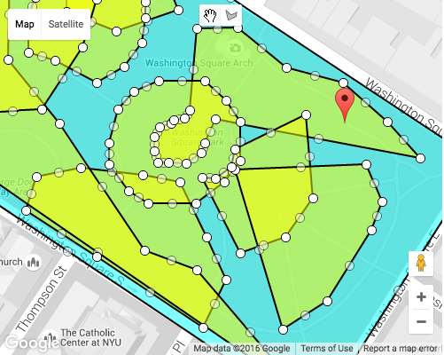

**Figure 9. – Closeup of *Initiation*; sound installation programmed utilizing Eonta’s boundaries.**

This piece is very simple and textural, but considerations of key and the nature of the tracks complimenting one another at any point in their temporal structure were made in the initial stages within the DAW. Ableton Live 9 provides a very supplemental framework to compose music for Eonta. By working in the session view and turning off grid-timing to the clock, the user is able to gain an understanding of how the loops play through each other asynchronously.

**V: PRELIMINARY RESULTS:**

**5.1.0 WEBSITE PERFORMANCE:**

Using a speed test provided by Google Developers’ “PageSpeedInsights”, Eonta performed with a score of 34/100 for a mobile platform, as well as 37/100 for a desktop computer. “Should Fix” level suggestions included the need to enable compression as well as minifying the JavaScript. “Consider Fixing” level suggestions were to eliminate render-blocking JavaScript and CSS in above-the-fold content, needing to leverage browser caching and to also minify the CSS. The rules passed by Eonta included the lack of redirects in the page, minifying the HTML – as a result of using Jade, optimizing the images – presumably because images were hosted by third party applications, prioritizing visible content and reducing the server response time Additional third party speed tests from webpagetest.org, pingdom.com and GTmetrix.com all indicated page load times between 3.4s to 3.7 seconds (webpagetest.org, pingdom.com and GTmetrix.com).

Using a site audit within the Inspector window in Google Chrome, red flags were passed regarding the suggestion to combine external JavaScript files – 9 resources being served from eonta.herokuapp.com and 33 from maps.googlemapsapis.com. Other issues regarding leveraging browser caching included the lack of a cache expiration on the Amazon s3 bucket regarding the uploaded audio files.

**5.2.0 AUDIO PLAYBACK:**

Audio performance utilizing *Initiation* during *Audition Mode* was faultless. There was no significant latency between the audio triggers, including when all tracks were triggered simultaneously. Playback on iOS was also instantly responsive with both play and stop events occurring with minimal delay. When uploading a 35.4 MB 16-bit Ogg Vorbis file with a sample rate of 44.1kHz, at an upload rate of 3.2 Mbps, the file took 12.8 seconds to finish.

When adding the listener in *Audition Mode* to the audio boundary, the file would take within a range of 10.6 to 11.5 seconds of the upload speed after ten trials. A second 21 MB Ogg file was uploaded at the same rate of 3.2 Mbps, the file took 8.6 seconds to finish. When the listener was added to the second boundary, the file would took 6.5 seconds, however after three trials the range remained consistently between 2.6 and 3.4 seconds (Figure 11.).

|  |  |  |  |  |  |
| --- | --- | --- | --- | --- | --- |
| **FILE:** | **1** | **2** | **3** | **4** | **5** |
| **SIZE (MB):** | **34.5** | **21** | **12.9** | **10.1** | **6.4** |
| **UPLOAD (s):** | **12.8** | **8.6** | **5.7** | **5.3** | **4.6** |
| **PLAYBACK TRIAL:** | |  |  |  |  |
| **Latency(s) 1** | **10.9** | **6.5** | **1.8** | **1.1** | **0.9** |
| **2** | **10.6** | **4.1** | **1.4** | **1.2** | **0.9** |
| **3** | **11.1** | **3.4** | **1.6** | **1.2** | **0.6** |
| **4** | **11.5** | **2.7** | **1.6** | **1.3** | **0.9** |
| **5** | **11.2** | **2.6** | **1.5** | **1.3** | **0.6** |
| **6** | **11.1** | **3.1** | **1.6** | **1.3** | **0.7** |
| **7** | **10.8** | **2.7** | **1.4** | **1.2** | **0.8** |
| **8** | **11.1** | **2.8** | **1.6** | **1.3** | **0.8** |
| **9** | **11.5** | **2.6** | **1.6** | **1.2** | **0.6** |
| **10** | **11.2** | **2.6** | **1.6** | **1.3** | **0.6** |

**Figure 11. – Upload Speed & Playback Latancy vs. File Size**

**5.3.0 GOOGLE MAP API RESULTS:**

While the map interface maintains the simplicity and ease of use as expected by the Google API, there were noticeable detriments to the user experience regarding how the program is applied. First and foremost, there was a tendency for the map to drift when used within iOS, and an inability for the user to zoom in on the screen without inadvertently zooming into an unusable position on the map. Although it read the audio boundaries with significant stability and accuracy, it was much less formidable on a small screen. Although the user who is navigating an IAE in real time will not need map stability to meet the benefit of the program, it does prevent them from seeing the boundaries clearly for further navigation.

**VI: DISCUSSION & FUTURE WORK:**

Eonta was designed to be a compositional utility for artists and musicians who are interested in a streamlined and enjoyable platform for topographical composition, which will not require a steep learning curve or a requirement to know a programming language to realize their compositional aspirations. In the examination of past works within this field of study, the author designed Eonta to fulfill the breadth of history associated with IAE’s while expanding on its accessibility and functionality.

**6.1.0 COMPOSING WITH EONTA:**

Given the minimalist nature of Eonta’s interface and the stability of its architecture, there is little reason to believe that a user who is already familiar with composition on a computer would have difficulty managing the interface requirements. Moreover, since it is the sum of many tools that are already intrinsically familiar to the general public, i.e. the Google Maps interface with the addition of a Photoshop-style drawing tool, the author is encouraged that future studies regarding the testing the prototype will result in positive associations with the application.

Through the practice of building IAE’s with Eonta, there certainly are behavioral and practical methodologies that support the program more than others. For example, learning to balance the file size for optimum playback speeds and higher levels of intricacy in the loop structure is a key element in the compositional process. Attention also needs to be given to the environment itself, as traditionally realized by groundbreaking installation pieces such as Stefan Schemat’s *Wasser.*

**6.2.0 FUTURE INTERFACE DEVELOPMENT:**

Later versions of the Eonta application will maintain the same basic nature of the program, however, there are a great deal of improvements that could make it much more versatile. Specifically, regarding making the map more accessible to those using the program on iOS. To encourage a more organized navigable experience, the Google Maps Places Library could also be utilized to incorporate a locational search engine, enabling the user to instantly isolate any global position with which they can work off of. The feature will increase the user’s ability to quickly search access addresses and prominent points of interest.

Other potential improvements to the application could include more of the tools and routing capabilities found within a DAW. The ability to mix, add filters, effects, dynamic processing and most importantly the potential for creating automation layers would add a much deeper level of creativity to a composition. Future versions will also require the ability to control a fade element between boundaries, allowing for an elegant transition between boundaries.

**VII: CONCLUSION:**

Eonta was developed with the intention of allowing people to explore their environments in a novel way. It benefits from a powerful and low-cost architecture, which contributes a great deal from the open-source web design community. Although the features of the prototype are limited, its core functionality still evokes an extensive history of avant-garde and experimental compositional techniques. With future user testing and more feature development, the Eonta prototype will be a distinctly creative and accessible means for building Immersive Audio Environments on the fly.

**VIII: REFERANCES:**

Sullivan, M (2012, August 9). A brief history of GPS. Retrieved October 14, 2015, from <http://www.techhive.com/article/2000276/a-brief-history-of-gps.html>

À propos. (n.d.). Retrieved October 2, 2015, from http://www.audiotopie.com/etude-de-cas/%C3%A0-propos

Conway, F., & Paterson, N. (2010). Spatial Audio and Reverberation in an Augmented Reality Game Sound Design. Presented at the Audio Engineering Society Conference: 40th International Conference: Spatial Audio: Sense the Sound of Space, Audio Engineering Society. Retrieved from <http://ezproxy.library.nyu.edu:3779/e-lib/browse.cfm?elib=15532>

Delerue, O., & Warusfel, O. (2002b). Authoring of Virtual Sound Scenes in the Context of the Listen Project. Presented at the Audio Engineering Society Conference: 22nd International Conference: Virtual, Synthetic, and Entertainment Audio, Audio Engineering Society. Retrieved from <http://ezproxy.library.nyu.edu:3779/e-lib/browse.cfm?elib=11122>

Erne, M. (1995). Combining MPEG, PCMCIA, ISDN, and GPS for Professional Audio Applications. Presented at the Audio Engineering Society Convention 99, Audio Engineering Society. Retrieved from <http://ezproxy.library.nyu.edu:3779/e-lib/browse.cfm?elib=7696>

Harma, A., Jakka, J., Tikander, M., Karjalainen, M., Lokki, T., & Nironen, H. (2003). Techniques and Applications of Wearable Augmented Reality Audio. Presented at the Audio Engineering Society Convention 114, Audio Engineering Society. Retrieved from <http://ezproxy.library.nyu.edu:3779/e-lib/browse.cfm?elib=12495>

iPhone’s GPS lets music morph as you meander. (n.d.). Retrieved November 14, 2014, from http://www.cnet.com/news/iphones-gps-lets-music-morph-as-you-meander/

Janer, J., Kersten, S., Schirosa, M., & Roma, G. (2011). An Online Platform for Interactive Soundscapes with User-Contributed Audio Content. Presented at the Audio Engineering Society Conference: 41st International Conference: Audio for Games, Audio Engineering Society. Retrieved from <http://ezproxy.library.nyu.edu:3779/e-lib/browse.cfm?elib=15750>

Karjalainen, M., Lokki, T., Nironen, H., Harma, A., Savioja, L., & Vesa, S. (2004). Application Scenarios of Wearable and Mobile Augmented Reality Audio. Presented at the Audio Engineering Society Convention 116, Audio Engineering Society. Retrieved from http://ezproxy.library.nyu.edu:3779/e-lib/browse.cfm?elib=12759

Kwastek, K. (2013). Aesthetics of Interaction in Digital Art. Cumberland, RI, USA: The MIT Press. Retrieved from <http://www.ebrary.com>

Reub, T. (2002). Sonic Space-Time: Sound Installation and Secondary Orality. Consciousness Reframed.

Thompson, T. B. (1998). Building an Audio Wide Area Network. Presented at the Audio Engineering Society Convention 105, Audio Engineering Society. Retrieved from <http://ezproxy.library.nyu.edu:3779/e-lib/browse.cfm?elib=8417>

Wong, K., & Tanaka, K. (2014). Data embedding for geo-tagging any contents in smart device. In *2014 IEEE Region 10 Symposium* (pp. 527–530). <http://doi.org/10.1109/TENCONSpring.2014.6863090>